**Nama : Adian Safrida**

**Tugas Membuat Query (Join, Right Join, Left Join)**

1. SELECT pembeli.id_pembeli, nama, no_telp, alamat

FROM `pembeli`

JOIN barang ON pembeli.id_pembeli = barang.id_pembeli

ORDER BY id_pembeli ASC

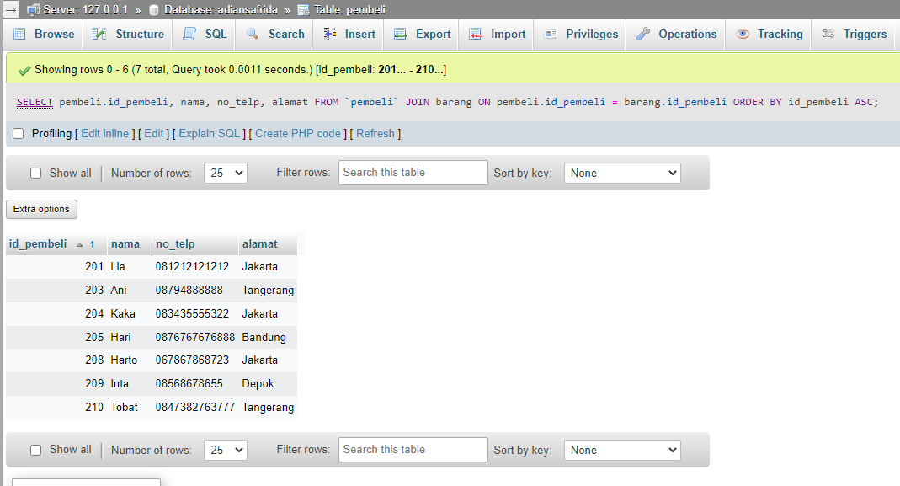

1. SELECT pembeli.id_pembeli, nama, no_telp, alamat

FROM `pembeli`

RIGHT JOIN barang ON pembeli.id_pembeli = barang.id_pembeli

ORDER BY id_pembeli ASC

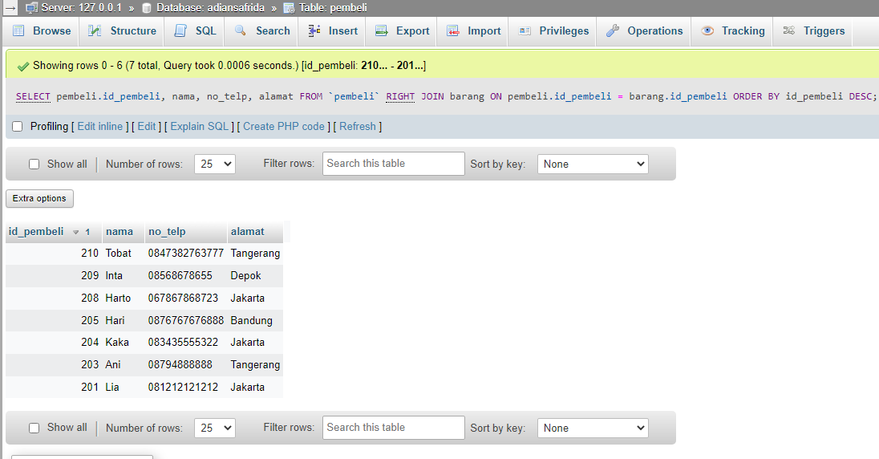

1. SELECT pembeli.id_pembeli, nama, no_telp, alamat

FROM `pembeli`

LEFT JOIN barang ON pembeli.id_pembeli = barang.id_pembeli

ORDER BY id_pembeli ASC

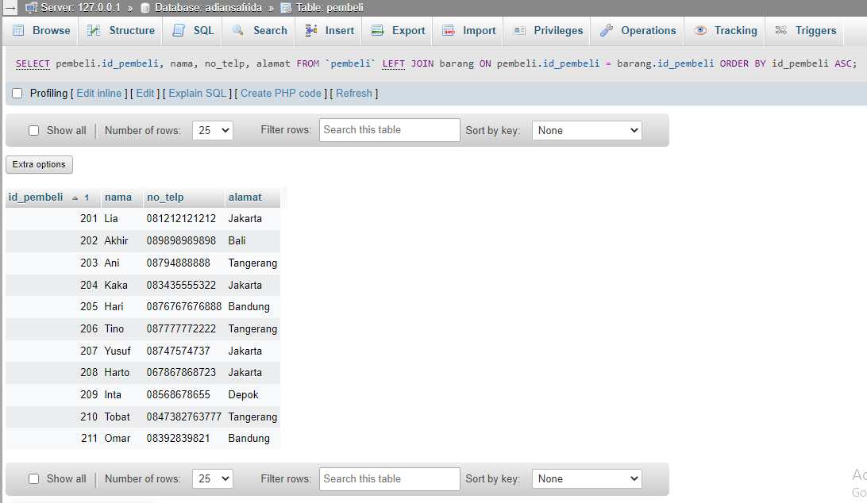

1. SELECT pembeli.id_pembeli, nama, no_telp, alamat

FROM `pembeli`

JOIN barang ON pembeli.id_pembeli = barang.id_pembeli

WHERE alamat LIKE '%Jakarta%'

ORDER BY id_pembeli ASC

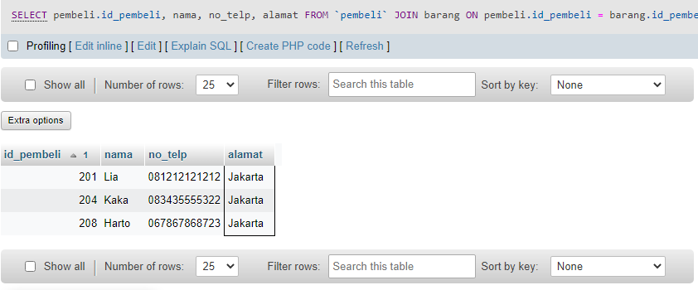

1. SELECT pembeli.id_pembeli, nama, no_telp, alamat

FROM `pembeli`

LEFT JOIN barang ON pembeli.id_pembeli = barang.id_pembeli

WHERE alamat LIKE '%Jakarta%'

ORDER BY id_pembeli DESC